Title: | Curriculum Policy
Internal Reference: | L4L-GY-020
Approved by: | Claire Bramley
Date amended | 15.4.2025
Version No: | V6
Date for renewal | 1.8.2026

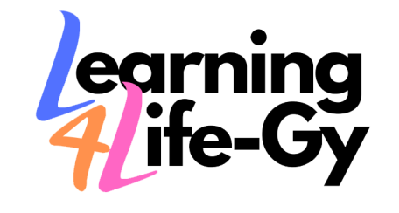

Learning4Life-GY

Curriculum Policy

Introduction
Learning4life-GY is a school for learners at Key Stage 3 and Key Stage 4 (Aged 14-19 years). Our learners have a range of complex learning needs, communication difficulties, social, emotional and mental health needs, or language as a barrier to education. Learners access places at Learning4life-GY through the Local Authority, either as a result of having an Educational and Health Care Plan (EHCP) or as they have been placed within North East Lincolnshire as an Unaccompanied Asylum seeking child (UASC). Learners with a language barrier may also be commissioned for step out placed by their primary school for additional English language support. Learners at Learning4life-GY have barriers to learning which may include the following:
- Long periods of absence from school
- 1:1 support either at home or in an educational setting, potentially on a part time basis
- Low self-esteem in relation to their ability to engage with school, or in controlling their emotions.
- Low aspirations for what they will progress into when they leave school
- A diagnosis such as ADHD, ASD, ODD, SLCN and specific learning difficulties such as dyslexia.
- Previous and current trauma experiences
- Limited or no English language skills
Learning4life-GY offer an environment where learning is interpreted in its widest sense. The curriculum includes both formal learning within a lesson, and informal learning outside of the classroom throughout the school day. It is through the development of learning experiences that staff promote learning, personal growth and development. Such experiences are structures to ensure that they have the greatest impact on the outcomes, attainment, progress and personal development of all of our learners.
Our Mission Statement
To provide high quality, individualised and culturally inclusive ‘Stepping-Stone’ education to the most deprived, disadvantaged, and marginalised groups in North-East Lincolnshire.
Our Ethos
To provide a safe and supportive school community that enables learners to develop the knowledge and skills required to play a positive and successful role in our diverse society.

Our values

Ready – We demonstrate commitment to trying our best, engaging with learning and working together
Respectful – We work collaboratively to be a community where all individuals are treated with respect and equality
Safe – We have a safe environment where everyone can be ambitious for themselves and others.

Curriculum Aims

The main aim of the curriculum at Learning4life-GY is to inspire and challenge learners and to prepare them for the future. The schools’ aim is to continually reflect upon the curriculum and develop learning experiences that build on learners already existing knowledge and skills. The curriculum must:

- Be fun, flexible and encourage a joy for learning
- Be aspirational and focused on high standards and expectations.
- Enable those who are not achieving expectation to narrow the gap and work towards meeting age related expectations and/or personalised targets.
- Value learning outside the classroom and curriculum, but relate to the taught curriculum
- Ensure the development of key functional skills including literacy, numeracy and technological skills
- Motivate and inspire learners to develop their personal, learning and thinking skills to become independent learners.
- Support and develop learners to achieve accredited qualifications when learners are ready for them.
- Stretch and challenge learners to achieve their potential and a commitment to lifelong learning.

Curriculum Outcomes

Learning4life-GY’s school curriculum is designed to:

- Deliver Quality first teaching through the promotion of a variety of teaching styles that enrich learning.
- Encourage curiosity, critical thinking and the ability to apply both cognitive and physical skills effectively.
- Align with the National Curriculum wherever possible, ensuring breadth of subject and clear progression
- Lead to qualifications that are valued by employers and further education provision.
- Be delivered in a nurturing and supportive environment, where positive relationships foster a sense of safety and promote academic and personal growth
- Provide a range of opportunities for learning outside of the classroom by offering access to a wide range of learning opportunities that go beyond the statutory framework
- Address the variety of learning, social, emotional and mental health needs of every learner
- Equip learners with the knowledge and skills to ensure smooth transition within and across educational phases

Structure of the school day

14-19 Learners (975 hours)

The school operates a 39 week academic year with 25 period per week, 5 period per day. Each period is 1 hour in duration.

All morning sessions for 14-16 year old learners are classroom based. All afternoons session are vocational learning focused. The final 2 periods every Friday are used to support the school’s curriculum enrichment by offering a range of activities both on and offsite.

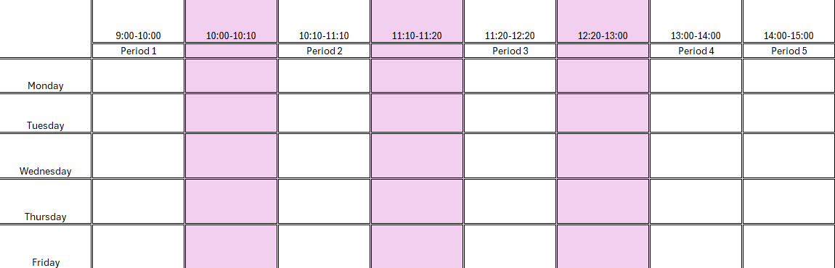

16-19 Learners - All (702 hours)

The school’s sixth form provision operates a 39 week academic year with 18 periods per week, 5 periods per day. Each period is 1 hour in duration.

All afternoon session for 16-19 year old learners are classroom based. All morning sessions are focused on the main study programme qualification.

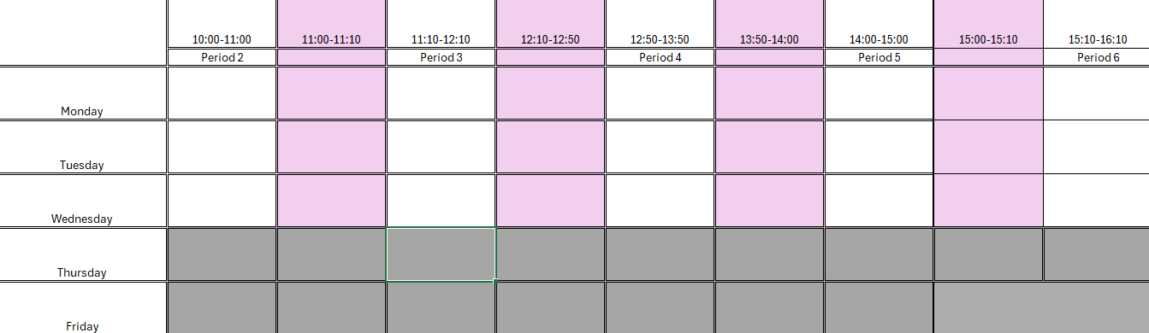

Formal Curriculum structure

14-16 Learners

A national Key stage 3 and 4 curriculum is the main focus of all AM lessons at Learning4life-GY. Our curriculum model is based on the core national curriculum foundation subjects, taught on a modular basis. The modular organisation allows for subject delivery to be flexible and either aligned with the national curriculum model, or thematically in line with the topic area, based on learner need.
Learners are grouped in accordance with their level of ability in Maths and English, this enables the more able learners to be extended, whilst allowing learners needing more support to obtain this through greater differentiation. In all AM sessions, accredited courses are followed in Maths, English, Science and Digital Technology and non-accredited PSHE is mandatory.
The PM session are designed to focus upon the development of social, emotional, physical and creative knowledge and skills. All PM session will be vocationally and practically based. PM sessions will include PE, Design and Technology, Food Technology, Humanities, Performing Arts, Art and Music. In Year 11, learners will be able to work towards accredited Awards in these subject areas if they are ready to do so.
Tutorials are delivered each week and are utilised as a space and time to monitor the social and emotional development and engagement in learning for all learners. It is during tutorials that progress towards learner EHCP outcomes is monitored and the personalised pathways of each learner are produced and reviewed. In Year 11, a Careers curriculum is delivered in tutorials that supports learners to develop actions plans which contribute to multi-agency transitional review meetings. The outcome is to ensure that learners have all relevant support needed to make appropriate choices Post 16 and beyond.
Throughout all phases, weekly whole school assemblies will be held on a Monday Period 4 to celebrate learner success, discuss any themes from our Equality and Diversity calendar and highlight any in the moment priorities and themes.

16-19 Learners
At Post 16, learners will choose between 3 Study Programme Pathways:
- Uniformed and Public Services
- Care and Health
- Digital and Creative Technology
Learners will be grouped according to their pathway and each AM session will be focused upon their achievement of a Level 1 or 2 Award, Certificate or Diploma in their chosen programme pathway.
In all PM sessions, accredited courses in Math, English and Science will be followed.
Tutorials are delivered each week and are utilised as a space and time to monitor the social and emotional development and engagement in learning for all learners. It is during tutorials that progress towards learner EHCP outcomes is monitored and the personalised pathways of each learner are produced and reviewed. For Post 16 learners a PSHE curriculum is also delivered in tutorials to ensure any emerging Year 12 and 13 PSHE themes that emerge are thoroughly covered, this includes preparation for careers and transitions to adulthood.
Throughout all phases, weekly whole school assemblies will be held on a Monday Period 4 to celebrate learner success, discus any themes from our Equality and Diversity calendar and highlight any in the moment priorities and themes.
Post 16 ESOL Learners
The Post 16 ESOL curriculum is focused upon learner achievement of the ESOL Skills for Life Certificate which covers all Reading, Writing and Speaking, Listening and Communication awards. 7 periods (50%) of the curriculum will be dedicated to achievement if this accredited study programme. Further focus on development of the English language will be delivered through sessions on vocational English and Citizenship. The main aim of this curriculum is to support learners into Post-16 vocational programmes with the general and vocationally relevant English skills needed.
Alongside English delivery, Learners will have a thorough Functional Skills Maths programme and Science lessons delivered, ensuring that further key skills are developed alongside the English language required to access further education and employment in the UK.
Each week, learners will have the opportunity to develop their vocational and physical skills in engagement with employment related activity and/or work experience. This will be tailored to the vocational areas that interest the learners and support them to gain relevant experience in order to progress to vocational programmes or employment elsewhere.

Careers education
Learning4Life-GY is committed to providing a planned programme of careers education activities to all year groups, including the opportunity for all students to access impartial information and expert independent advice and careers guidance. Learning4Life-GY is also committed to maximise the benefits for all students by adopting a whole school approach involving parents, carers, external IAG providers, employers and other local agencies, the wider community and FE and HE establishments. In compliance with the DfE government guidance, Learning4Life-GY will:
- Ensure that students are aware of the full range of career opportunities available
- Learn from employers about valued workplace skills and have an opportunity to first-hand workplace experience. (exclusions apply*)
- Offer an excellent programme of advice and guidance delivered by qualified advisers with support tailored to the individual
- Provide information needed to understand job and career opportunities available and how knowledge and skills can help towards career paths
- Give a range of providers of technical education and apprenticeships the opportunity to access all pupils
- Publish details of career programmes for young people and parents and carers
- Ensure students have at least 1 meaningful encounter with employers per year
- All pupils will have access to Lincs2 for research and application
- All pupils will have a dedicated entitlement.

Curriculum Enrichment
Curriculum enrichment is embedded within every subject that is delivered. We ensure that each area have visits and trip opportunities that bring to life the curriculum delivery and enable learners to explore concepts themselves with hands-on activities. We utilise the skills of our staff, and others outside of the school environment, to create enrichment opportunities for all learners.
In addition to curriculum enrichment, we offer learners an enrichment programme that enables the practice and development of skills in an informal learning environment every week. This enrichment programme provides a body of knowledge and skills for each learner with no academic pressure or judgements of performance. Here learners are encouraged and supported by trusted staff, through the enrichment programme, to develop life skills which build character and benefit well beyond the classroom. Learners are given this opportunity every Friday PM and can experience an ever changing choice of activities and special interests. Such activities include:
- Countryside exploring
- Fishing
- Cooking
- Discovery
- Fitness
- Minecraft
- Football academy
- Performing Arts
- Music
- Art
Interventions
Interventions will be designed according to learner EHCPs and may take a variety of forms, depending on learner needs. At each termly review period, tutors will meet with learners and discuss the challenges that they experience and complete/ update their My Plans. It is here that appropriate academic, social or emotional interventions will be discussed to address specific needs. Once allocated an intervention will begin. Interventions will take many forms and will be delivered in a variety of ways, depending on the needs of the learner. My Plans will be used three times annually to identify areas of strength and relative weakness and evaluate the efficacy of any intervention accessed.
Allocated timeslots on each learner timetable will be available for intervention delivery. This will take place every Monday PM and learners will be allocated to groups dependent upon their specific needs as follows:
- Nurture – For learners with SEMH, attachment disorders and adverse childhood experiences. Interventions include personal development, Daisy Chain, TalkAbout activities. All delivery within the Nurture intervention will emphasise self-identity development, emotional literacy and resilience development
- Structure – For learners with Autism/ ASD. Interventions here will be based on sensory programmes, therapeutic approaches and the TEACCH strategy. Within the Structure intervention session will explore interests, social responsibility, explore ways of empathising with others; sensory integration and processing.
- Explore – For learners with SEMH and ADHD needs. Interventions here will focus on kinaesthetic approaches to achievement, will emphasise practical learning opportunities and vocational curriculums to support the development of practical and functional skills
- Inspire – For learners who are working academically at a high level who require more stretch and challenge. This intervention is a bespoke enrichment opportunity, emphasises stretch and challenge and intervention groups for high attainment. The emphasis is on developing confidence, independence and functional communication skills.
- Engage – For those who are transitioning to Learning4life-Gy with previous severe absences, those who are currently in crisis, experiencing trauma or severe anxiety. This intervention forms part of our commitment to supporting improvements in attendance through the provision of a reduced timetable, Thrive based intervention activity delivery and individualised action planning to support. This intervention will be supported by multi-agency partners, possibly access to CAMHS and focused on trauma informed approaches and positive relationship building.

